True Time Training - Supervisors
Log in to Skyward Employee Access – Make sure it says Mulvane, KS FINANCE https://skyward.iscorp.com/scripts/wsisa.dll/WService=wsfinmulvaneks/seplog01.w
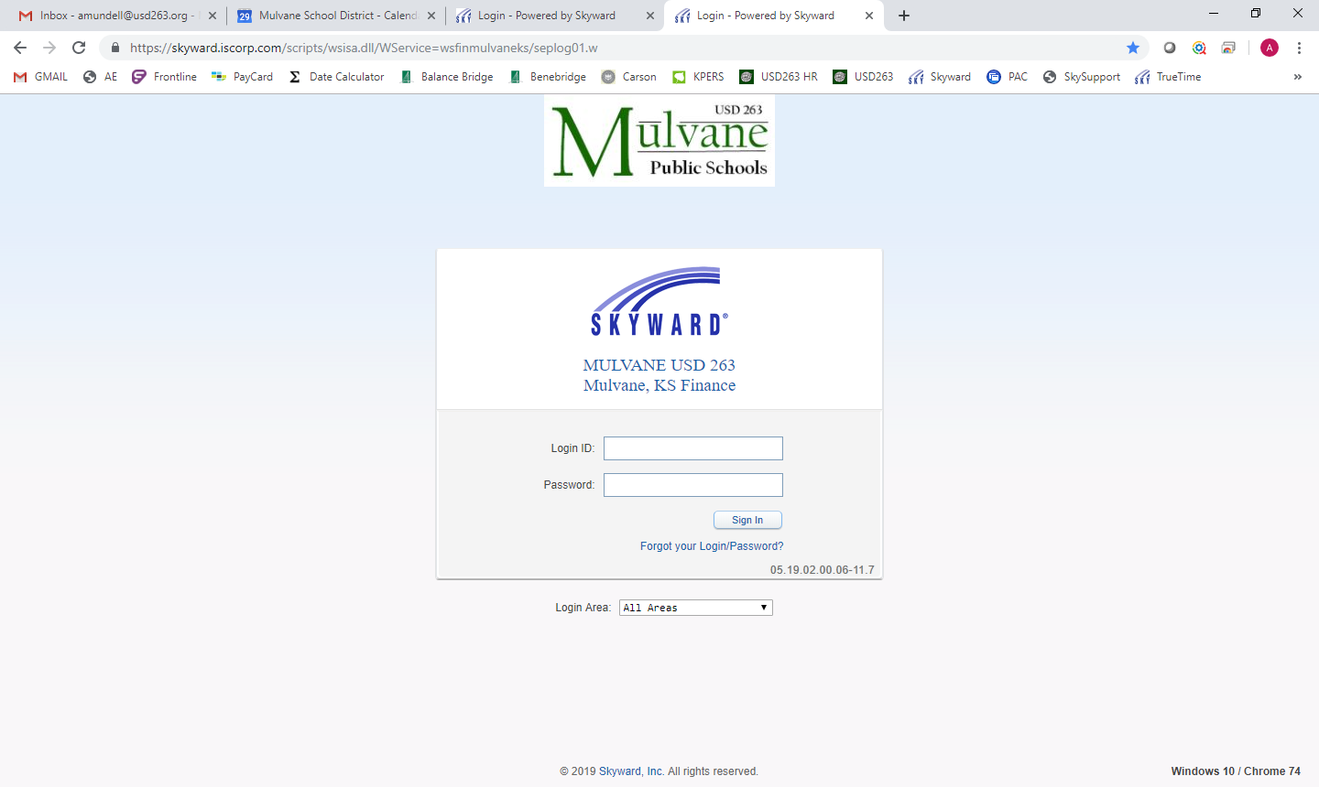
If it is your first time logging in use your first letter of first name and last name (amundell) and your password would be the last four of your social.
If you have logged in before and cannot remember your password please email me at amundell@usd263.org. I will have to reset your password.
Your home screen is called EMPLOYEE ACCESS and contains pertinent information to you and can be customized. Feel free to select widgets and move them around to whatever you like.
Here are few widgets that are recommended:
Time Sheets Waiting My Approval
- From here you can View / Edit / Approve / Deny Individual timesheets, Mass Approve Time Sheets, and Mass Print Time Sheets
True Time Max Hours (optional)
- Indicates who is close to overtime and you can look to see the hours worked for the week
Time Off Waiting My Approval
- This will list any employee time off requests. You are able to approve / deny individual or all requests. Also you can view all your employee’s absences on a calendar which can be very helpful and can help you determine if it is a good idea to approve the absence.
My Employee’s Time Off Per Week
- This is a bar graph that shows you all your employees and their requests off per week. It is interactive so you can click on bars to find out who is off those days.

My Time Off Status
- Lists your own personal time off balances and you are able to submit a time off request for yourself
- Click ADD TIME OFF REQUEST, Time off Code would be PTO / Reason PTO or Sick Admin Days / Reason Code Sick, enter description if you wish, single/multiple day, date, days and start time. You can also notify others of your absence, just click Select Employees. This sends an email to your supervisor for approval and shows up on their Employee Access home page.
-----------------------------------------------------------------------
Just a few other items to note on Employee Access:
Employee Information Tab
- This shows your personal info, calendar, check information and more
Time Off Tab
- Time Off – My Status – gives you balances of your leave
- Time Off – My Requests – shows past leave requests, whether they were approved / denied and you can also ADD a leave request from this screen (follow directions above)
- Time Off – My Approvals – For reports of your requested time off, you can sort by different views
- Time Off – My Employees – Shows your employees leave balances and you can add Time Off Transactions here
True Time Tab
- True Time – Data Mining – where you are able to create and set up your own reports
- True Time – Reports – pre-populated reports you are able to run
- Supervisor Access – My Employees True Time – View/Edit punches, make notes, etc.
- Supervisor Access – My Employees Totals by Status – View weekly totals for past six weeks
- Supervisor Access- My Employees Weekly Averages – View weekly averages
- Supervisor Access – Schedule Tracker – View Employees Schedule
- Supervisor Access – Max Hours - Indicates who is close to overtime and you can look to see the hours worked for the week
- My employees Time Sheets – Unsubmitted – view all unsubmitted time sheets
- My employees Time Sheets – Unapproved – View / Edit / Approve / Deny Individual timesheets, Mass Approve Time Sheets, and Mass Print Time Sheets
- My employees Time Sheets – History – view for a timeline of the time sheet

Additional Information – Links to Tutorials
Time Off - My Approvals
https://support.skyward.com/DeptDocs/Corporate/Documentation/Public%20Website/Tutorials/Software/WA_EM_TO_1327203_310_T.htm

Time Off - My Employees Time Off
https://support.skyward.com/DeptDocs/Corporate/Documentation/Public%20Website/Tutorials/Software/WA_EM_TO_1327203_320_T.htm

True Time - Edit Existing Times
https://support.skyward.com/DeptDocs/Corporate/Documentation/Public%20Website/Tutorials/Software/WA_EM_TT_TT_QE_1749274_110_T.htm

True Time - Add a Missing Record
https://support.skyward.com/DeptDocs/Corporate/Documentation/Public%20Website/Tutorials/Software/WA_EM_TT_TT_QE_1749274_120_T.htm

True Time - Delete Record
https://support.skyward.com/DeptDocs/Corporate/Documentation/Public%20Website/Tutorials/Software/WA_EM_TT_TT_QE_1749274_130_T.htm

True Time - My Employees TrueTime
https://support.skyward.com/DeptDocs/Corporate/Documentation/Public%20Website/Tutorials/Software/WA_EM_TT_SA_ET_1752255_100_T.htm

True Time - My Employees Totals by Status
https://support.skyward.com/DeptDocs/Corporate/Documentation/Public%20Website/Tutorials/Software/WA_EM_TT_SA_TS_1752268_100_T.htm

True Time - My Employees Weekly Averages
https://support.skyward.com/DeptDocs/Corporate/Documentation/Public%20Website/Tutorials/Software/WA_EM_TT_SA_WA_1752275_100_T.htm

True Time - Schedule Tracker
https://support.skyward.com/DeptDocs/Corporate/Documentation/Public%20Website/Tutorials/Software/WA_EM_TT_SA_ST_1752279_100_T.htm

True Time - Employee Locator
https://support.skyward.com/DeptDocs/Corporate/Documentation/Public%20Website/Tutorials/Software/WA_EM_TT_TT_EL_1749398_100_T.htm

True Time - My Employees Time Sheets - UNSUBMITTED
https://support.skyward.com/DeptDocs/Corporate/Documentation/Public%20Website/Tutorials/Software/WA_EM_TT_TS_US_1752297_100_T.htm

True Time - My Employees Time Sheets - UNAPPROVED - Reviewing Unapproved Time Sheets
https://support.skyward.com/DeptDocs/Corporate/Documentation/Public%20Website/Tutorials/Software/WA_EM_TT_TS_UA_1752320_100_T.htm

True Time - My Employees Time Sheets - UNAPPROVED - Individually Approving Unapproved Time Sheets
https://support.skyward.com/DeptDocs/Corporate/Documentation/Public%20Website/Tutorials/Software/WA_EM_TT_TS_UA_1752320_110_T.htm

True Time - My Employees Time Sheets - UNAPPROVED - Mass Approve Unapproved time Sheets
https://support.skyward.com/DeptDocs/Corporate/Documentation/Public%20Website/Tutorials/Software/WA_EM_TT_TS_UA_1752320_120_T.htm

True Time - My Employees Time Sheets - UNAPPROVED - Mass Print Time Sheets
https://support.skyward.com/DeptDocs/Corporate/Documentation/Public%20Website/Tutorials/Software/WA_EM_TT_TS_UA_1752320_130_T.htm

True Time - My Employees Time Sheets - HISTORY
https://support.skyward.com/DeptDocs/Corporate/Documentation/Public%20Website/Tutorials/Software/WA_EM_TT_TS_HI_1752349_100_T.htm

