Google Calendar Hyperdoc
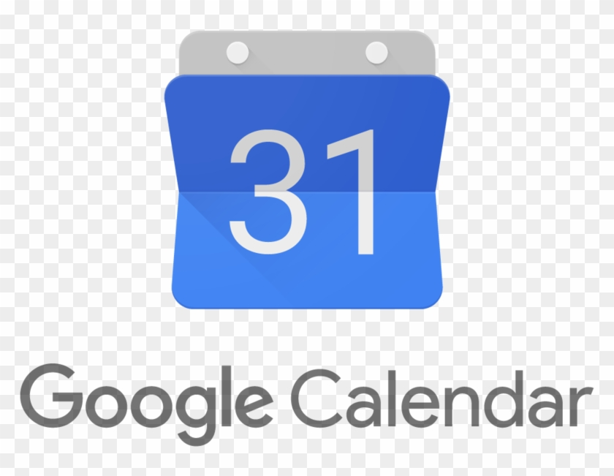 | What is Google Calendar?  https://docs.google.com/presentation/d/1mqEzyEl_S9bXE7i1YSk4xP_yyHjpxPtdIo8sYPh2uds/edit?usp=sharing
Benefits of Using Google Calendar

https://www.lifehack.org/articles/technology/how-google-calendar-can-make-your-life-lot-easier.html
Tasks and Assignments
Keep yourself on track and organized.
https://www.youtube.com/watch?v=Zdw3tbeVy9M

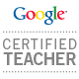 | More support for Google Calendar  - https://sites.google.com/site/cliotech/google-calendar
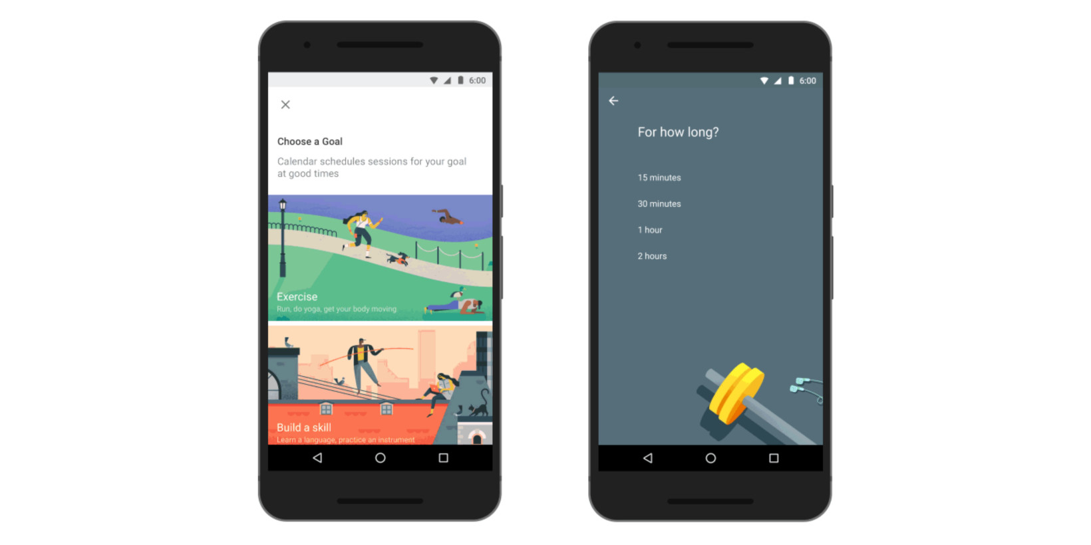 | Goals  - https://time.com/5659017/google-calendar-tips-tricks/?playlistVideoId=6076236051001
